Intro

*Introduce initial exercise*

Five interpretations, raise hands on which one you think is right.

1. Quantum mechanics means we don’t know anything precise about our particle since it’s some weird thing with some particle properties and some wave properties
2. The particle has a position and momentum, but if you get quite detailed information about the position by doing some measurement, you can only get vague information about the momentum
3. We can’t create instruments accurate enough to find the particle’s exact position/momentum, because when you make a measurement of position and it creates a disturbance in the measurement of momentum. For example, when hitting a particle with a photon/light to get its position, you need the light to have a very small wavelength, but it now has high energy/momentum which it gives to the particle, giving high uncertainty to momentum
4. The particle is always in a bunch of different positions and momentums, like a fuzzy ball instead of a solid particle, and we can never tell that fuzzy ball’s position and momentum to a certain precision
5. The particle has a lot of different positions and momentums, but if we say the particle is “mostly” in a very small range of positions, then it is “mostly” in a large range of momenta.

Why wrong

1. No, particle is fuzzy, but if it was *only* fuzzy we could minimise the fuzziness
2. No, can’t measure momentum and position at same time, nonsense
3. It’s not about measurement at all, it’s intrinsic property
4. It’s not *always* in a superposition, it has to collapse
5. Right

Now in my script, I’ve imagined that most of you didn’t get this right. So if you didn’t get it wrong well done.

If you did, I’m not surprised.

But one thing that’s interesting about this theory, is how wrongly interpreted it is. I mean you can see the equation, but there’s lots of ways people have managed to get this wrong. To me that’s one of the reasons why mathematics is so important in physics, it makes sure you actually understand what’s going on. Instead of just going, mm I move things with force, or hmm double slit experiment is a thing, it gives you theories you can apply to many different scenarios and experimentally verify.

Now saying that, this talk is probably not going to have much maths at all. So don’t pretend as if everything here is a rigorous proof, because 1. I barely understand what I’m doing and 2. This is very very very non-rigorous

There might be a part 2 of this where I actually go through the derivation and stuff, but I think that would take about 40 min.

Anyway but hopefully I’ll be able to explain what this actually means. * show equation*

The most important thing I hope I’m able to explain is that HUP is not about measurement.

I’ll repeat again. HUP is not about measurement. It is actually a mathematical consequence of quantum mechanics’ rules.

(Maybe explain Heisenberg’s thought experiment, e.g. why so many people get it wrong)

But before we get to this bad boy, I think a tiny bit of ground work is useful.

So quantum mechanics in 5 minutes. Ok so this is a wavefunction.

It contains all the info we could have about our quantum system. We like writing it as psi.

These things with hats are operators, we use them to act on the wavefunction to extract an observable value.

e.g. position operator, momentum operator

(show pictures)

And then we come to a thing called Born’s rule, it says that the modulus of the wavefunction squared is the probability density of finding the particle at a location.

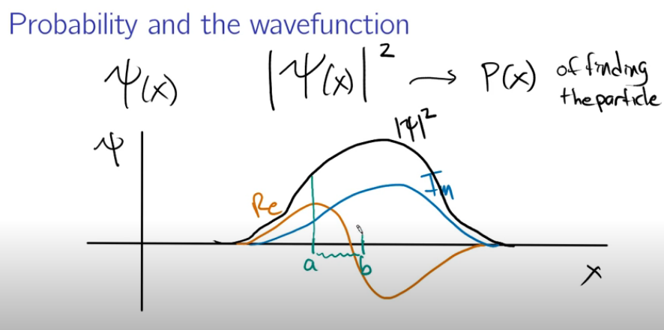

Since this is continuous, you can’t actually just choose a value of x to find it’s probability, you always need to select a range of xs.

In fact it’s actually the modulus of the wavefunction multiplied by its complex conjugate, but that’s just because we like real observables, like position and momentum.

But what it actually means, if we set up a bunch of identical states in the same position, and then we measured all of them identically, our spread is going to look like that. 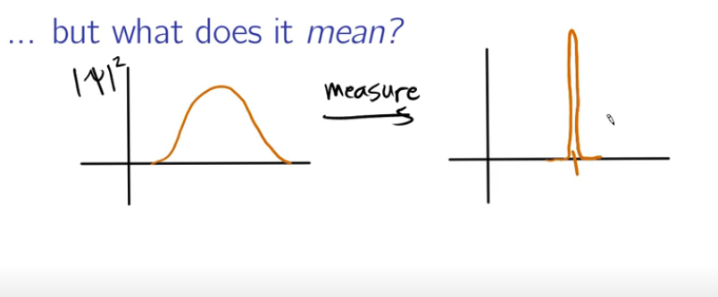

It doesn’t mean if we measured it a bunch of times in a row, we’d get a spread like that, because measuring changes the wavefunction. That’s called wavefunction collapse. And it’s extremely weird and we don’t know why it happens, it just does.

Before you go hmmm, what if I do this.

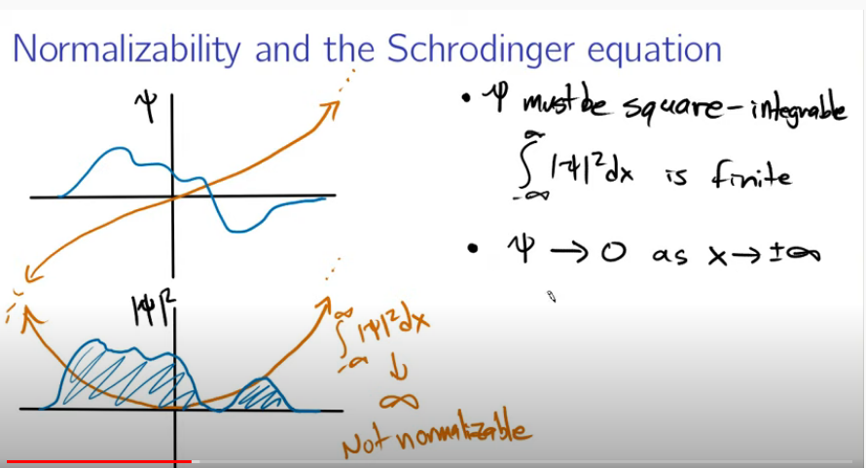

Born’s rule applies to every situation (afaik) because all wavefunctions have to be square integrable, which means we basically need to be able to find the area under |psi|^2. That’s because we need to be able to multiply it by a constant to get it to equal one, as the sum of the probabilities should hopefully equal 1. That’s called normalization.

But getting back to probability distribution, this collapse is actually why the first statement we mentioned earlier is wrong. Once we measure position the state changes. After you measure position, the state changes. We can actually model this probability distribution as being a superposition of states, that collapses to one we measure. But this measured state can’t represent the whole superposition/probability distribution, if we wanted, we could measure the momentum of the collapsed state and get a value there. But that wouldn’t represent the whole probability distribution. And so, there isn’t really such a thing as measuring the position and momentum of a particle at the same time. The statement is about these probability functions, not the state of an individual particle.

And to actually show Heisenberg’s uncertainty principle, we’d need to create an ensemble. A bunch of identical states with the same initial conditions and look at the probability density created from that image.

I haven’t actually mentioned what “uncertainty” really means, which is represented by sigma here. What it actually is, is the standard deviation, or variance of the probability distribution. You might have heard of standard deviation before, such as in height. And this is a similar concept. Basically on average, how wide is this curve.

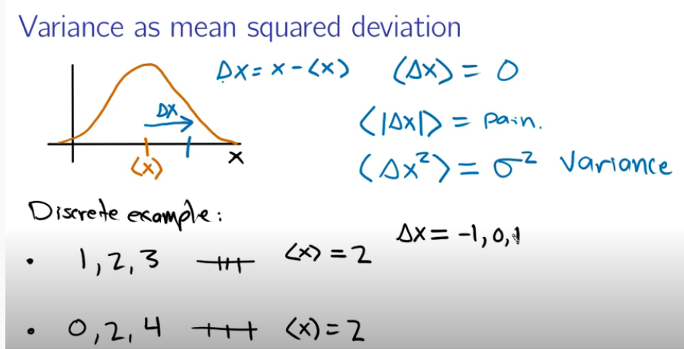

Here I’ll show how we actually get it. First we have an expectation value for our position <x>, I don’t want to spend too long explaining that but here it is. It’s essentially a fancy word for mean and you can think of it as the average position of the wavefunction if you want. Note this doesn’t mean that every particle you measure will be at that value, like if we had <p>=0, it’s just on average, when we measure it, it’s value will be zero.

So to calculate a mean you have this summation, the mean is the sum of each of the states, multiplied by the probability it will occur. And this is actually what this integral does, multiply each state by the chance of it happening. See examples here.

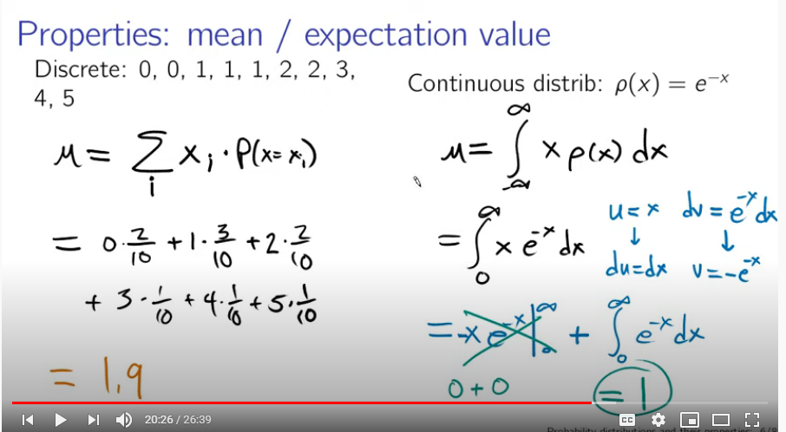

This actually turns out to be why the position operator is x, because to calculate the position a particle is somewhere, you use the



And so coming back to this, we want to see how wide this boi is. So you might tell me, Sean what if we try finding the distance of delta x from the average. Well this equals zero since we have both negative and positive dxs which cancel. Then you might tell me to find the modulus to get an actual number.

And if you’ve worked with moduluses in equations that is painful.

So what we end up doing is squaring dx, and we call this the variance.

Ok ok, so coming back now to HUP this means that the variance of momentum’s wavefunction and position’s wavefunction are somehow linked. Why do we care?

Well if they weren’t linked quantum stuff would still be very weird, but if you think about it there might be a way to squish down these probability densities so it doesn’t matter to us anymore. Sad news is that we can’t, this is because momentum and position are linked. When we squish one down, the other becomes wider.

So now when you look at this bad boi, you might ask me Sean, why the heck does this happen? If I were an average physics teacher I might tell you, well it is how it is. That is how physics do.

But I hate answer, I hate it very much. While it is a bit of a weird question, it’s like asking hmm Newton when move a thing, why does F=ma or rather dp/dt or change in momentum over time for the cultured folk here. He might say well because literally every time we do anything, this law works, so that’s why. And then we might get a smart pants saying well actually

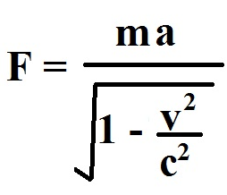

But unfortunately trains do not travel at 20% the speed of light in A level physics, so this doesn’t really matter.

Anyway it’s a bit of a weird question, but I think a decent attempt to answer it comes from showing where it ties into other things. A lot of people like using Fourier transforms to show this, but I don’t really want to. So we won’t.

I can give a very brief summary but this has no maths in so … take it as you will.

So a fourier transform is basically takes our wave, and tells us which frequencies make it up. So if we have a long wave here, it’s pretty easy to tell its frequency, but it’s hard to tell its position. And this also works the other way round. And basically De Broglie said matter is a wave because

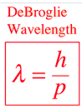

And position turns out to be the fourier transform of that wave. So… uncertainty.

I could also talk for an hour on the generalized uncertainty principle, which is actually applies to a lot of different things, basically all waves, but that’s for another day.

What I really want to do this use a bit of linear algebra though.

__

But first lets talk about some other stuff quickly. That other stuff is going to be commutators. We define a commutator to be

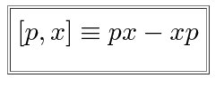

Using p and x as examples. Ok, so not too much interesting here so far. But now using our definitions of the position and momentum operator, we can work out the commutator of position and momentum

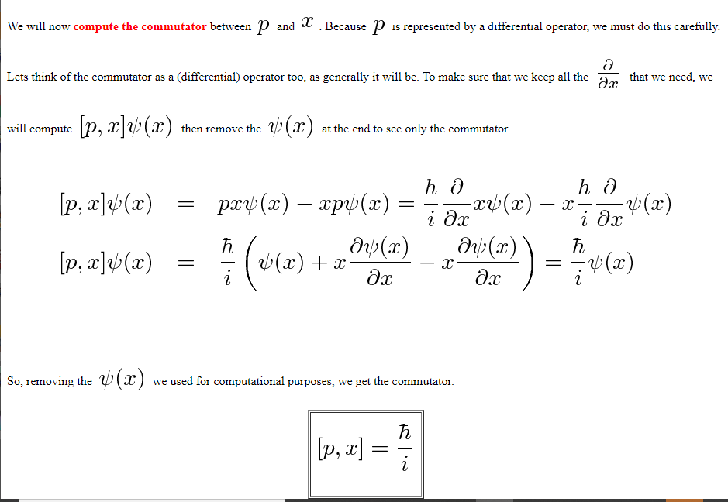

Nice

Btw I hope it’s kind of obvious where the position operator comes from, but I won’t talk about the momentum operator here since it’s a bit painful to derive from the Schrodinger equation. If I tell you it basically occurs from symmetry, meaning conservation of momentum, applied to Schrodinger equation I hope that’s enough for you

__

Ok so back to operators

We can also represent these operators as Hermitian matrices. I’m not going to do an introduction to linear algebra here but basically a matrix is Hermitian if it equals it’s transposed complex conjugate. I.e. all the stuff in the diagonal is symmetric, but complex conjugated

This is very nice, because all Hermitian matrices have real eigenvalues, and these eigenvalues represent the state of the system. Which is nice because I don’t like having an imaginary position. I shall not prove that but it’s pretty simple I think.

These matrices actually act in Hilbert Space, infinite dimensional space but all our linear algebra tools should still apply,

Anyway so measurable quantities in QM are eigenvalues of the corresponding operator. In order to get an eigenvalue (measurement), the particle must be in an eigenstate of the operator. That looks like

p|psi> = **p**|psi>

where p is the (momentum) eigenvalue, |psi> is the state, and **p** is the momentum operator. In order to get an eigenvalue of both **p** and **x** (position), you would need something like:

xp|psi> = **xp**|psi>

and

px|psi> = **px**|psi>

Because to have simultaneous measurement we don’t want the order we measure to matter.

Because if we say p|psi> = **p**|psi> and x|psi> = **x**|psi>

but this doesn't work because

**px**-**xp** =  ih bar

while px-xp=0. we get a nonsense expression because combining the equations gives

(xp-px)|psi> != (**xp-px**)|psi>

so there is no state |psi> which is a simultaneous eigenstate of **x** and **p**: it just can't happen.

This is nonsense because numbers i.e. eigenvalues commute but our operators here don’t, and so there is no state |psi> which is a simultaneous eigenstate of **x** and **p, or rather simply,** we can’t measure both momentum and position at the same time, doing so would give us nonsense, and so this shows how momentum/position are somehow linked.

And this had nothing to do with measurement, it's just how quantum states work.

You might tell me that our initial assumption that order shouldn’t matter doesn’t tell us we can’t measure them at the same time. I could say time is continuous, so there is no such thing at the same time, but I’ll give another example to make it more clear.

So now I want to look a little bit more closely at the definition of commutators. Rearranging it we get AB=BA, which means that the order of operations won’t matter if our operators commute. But then using these operators we get ABf(x)=BAf(x). This means if two operators commute, they have the same set of eigenfunctions (possible states), so from the same state, at the same time, we’re able to extract both observables represented by A and B.

However, if the operators don’t commutate it means that they don’t share the same set of eigenfunctions. What this means in practice, is that the set of possible states must change between measurements if our operators don’t commute, like position and momentum don’t.

And we can prove this. Let’s say we have some operators with the same eigenstates That if we want operators to have the same eigenfunctions i.e. to have the same states, they must commute.

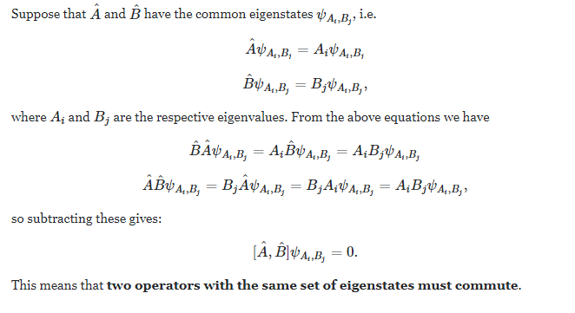

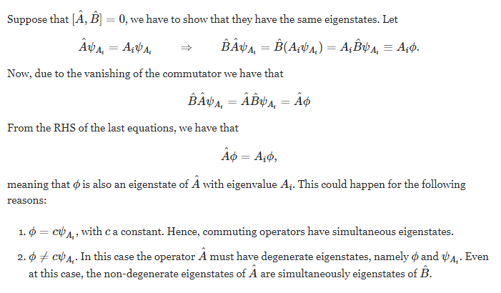(can also do backwards)

And so momentum and position can’t be measured at the same time because they don’t share the same set of possible states i.e. eigenstates.

And so commutators end up being pretty important, since they describe whether two things can be measured at the same time. And actually this principle is described in the generalised uncertainty principle.

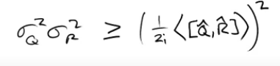

And this principle can be applied to a lot of different things, such as harmonic waves and it’s also what leads to energy time uncertainty.

If you plug in the commutator for momentum/position you’ll see you get the same thing.

equation

*read out equation*

So you might wonder whether this is a real principle of quantum mechanics or on what basis it is true. And that is actually an interesting question, because it can be interpreted as asking whether this is an empirical principle or constructive theory. To make that clear I’ll give an example, so a theory of principle or empirical theory is one which looks at empirical evidence (actual measurements) and builds stuff around it. Such as thermodynamics, where the empirical evidence is the impossibility of all sorts of perpetual motion machines, and then we built a very nice theory around that, made nice laws and terms of entropy and stuff, but then we can derive the results of the theory from these laws i.e. impossible to have perpetual motion, so it kind of become a chicken or the egg scenario.

Furthermore, some people might say that it isn’t a principle of quantum mechanics, since this consequence can be derived from other postulates, but you can’t derive all the other stuff from this. To be honest, I don’t really care too much about the answer, I just think it’s an interesting question. Why you believe in this principle basically depends on which starting points you choose to use.

(source)